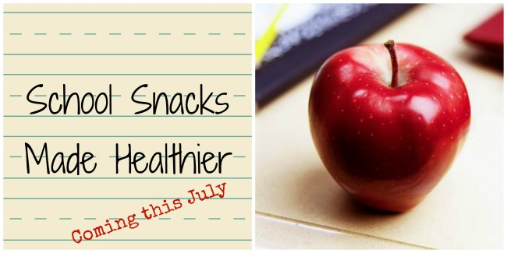

Take the hassle out of purchasing and delivering snacks to school for that special occasion by ordering nutritional snacks from the Central DeWitt Community Schools Nutrition Department. These snacks are all peanut and tree nut free items. All other allergens will be listed next to the products.

Child’s Name:_________________________________________________________________________________

Grade:______________________________________ Teacher:________________________________________

# of Children_______________________________

Contact person:____________________________ Phone Number:_______________________________

Choose one (1) Snack:

- Fresh Apples (fresh fruit)
- Cheddar Popcorn (milk)
- Racing Ranch Goldfish Crackers (wheat, milk)
- Rice Krispi Treats (milk & soy)
- Scooby Doo Fruit Snacks (These are GLUTEN FREE)
- Go-gurt These will served frozen. (milk) (GLUTEN FREE)
- Oven Baked Lays (soy)
- Scooby Doo Cinnamon Grahams (wheat, soy)
- Keeblers Animal Crackers (wheat, soy)
- Fruit by the Foot (contains pear juice)

Send order form and payment to: Central Community School District: Attn: Nutrition Service, 331 E 8th Street P.O. Box 110 DeWitt, Iowa 52742. Make checks payable to Central Community School District. Only prepaid orders received at least 1 week in advance will be filled and delivered.

Payment Due:__________________________ x $.75 =____________________________
# of Students Total

Date of Event:___________________________

Central DeWitt Community School District

Healthy Snacking = Healthy Kids

The Healthy Kid’s Act was created to improve the health of our children and a healthier environment in our schools. To assist with creating this healthier environment at Central DeWitt Community Schools, we ask for your cooperation in seeing that all treats and/or snacks offered at school meet the Healthy Kid’s Act requirements. The snacks must be individually wrapped with a label. Below is a list of examples of snacks approved for our school. To prevent possible allergic reactions, please send treats and snacks purchased at a store and have an ingredient label on the package stating the content of the food.

Classroom Treat/Snack List:

All fresh fruit (whole, the teacher will cut up)
All fresh veggies (whole. the teacher will cut up)
Goldfish crackers
100% fruit juice (must be in individual boxes)
Baked chips
Bottled water
Simply Chex Mix
Dried Fruit (all varieties)
Fig Newtons
Smart Foods Popcorn (low or no salt)
Pretzels
String Cheese
Yogurt/ Go-gurt
Quaker Kids Snack (Cereal Mixture)
Oreo Cookies
Cinnamon Teddy Grahams
Animal Crackers
Graham Crackers
Vegetable Chips
Rice Snacks
Cheese Nips

If there is an item not listed that you would like the district to consider as an acceptable snack idea, please contact Dede Wagener @ 563-659-4725 or dede.wagener@cd-csd.org.

Need help with treats/ snacks? Not a problem, order your child’s birthday treat through school. (See back for details)

